Table of Appendix Figures
Figure A. 1 - Command to run the Jenkins pipeline within docker. 2
Figure A. 2 - Iteration #1: The false positive 2
Figure A. 3 - Iteration #2: The First failure 3
Figure A. 4 - Iteration #3: Checkov pass – S3 bucket logical error 4
Figure A. 5 - Iteration #4: HITL removed S3 bucket logical error 4
Figure A. 6 - Iteration #5: Overly restrictive egress 5
Figure A. 7 - Iteration #6: Overly Restrictive KMS Policy 6
Figure A. 8 - Iteration #7: Allowing encrypt/decrypt for kms policy 6
Figure A. 9 - CKV2_AWS_12 failed example 7
Figure A. 10 - CKV2_AWS_12 Passed example 7

Appendices
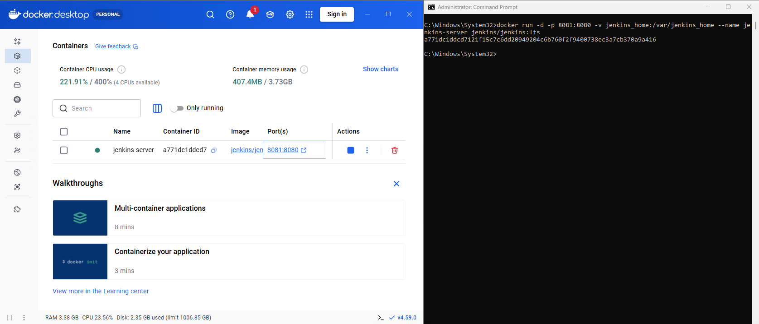
Figure A. 1 - Command to run the Jenkins pipeline within docker.
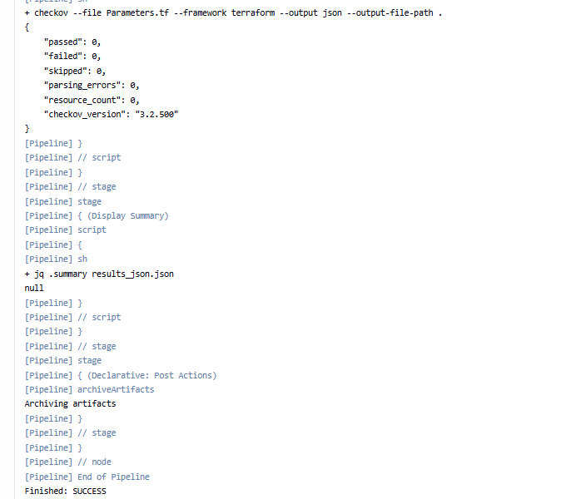
Figure A. 2 - Iteration #1: The false positive

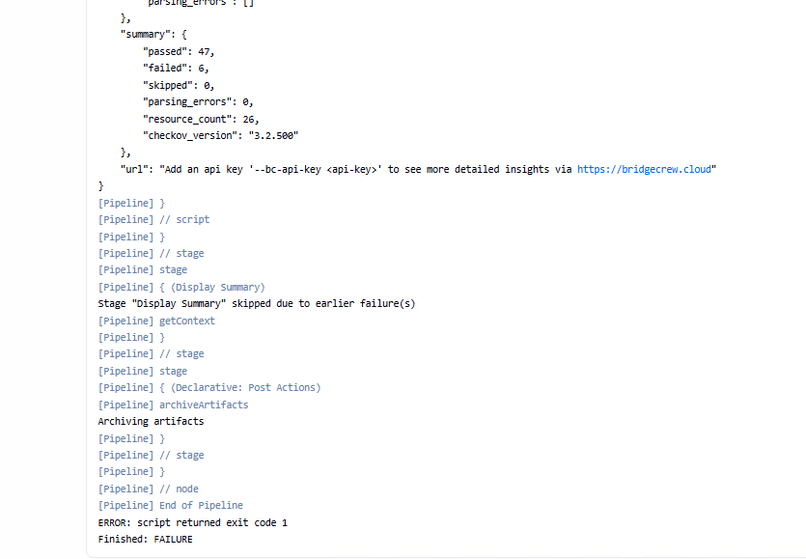
Figure A. 3 - Iteration #2: The First failure

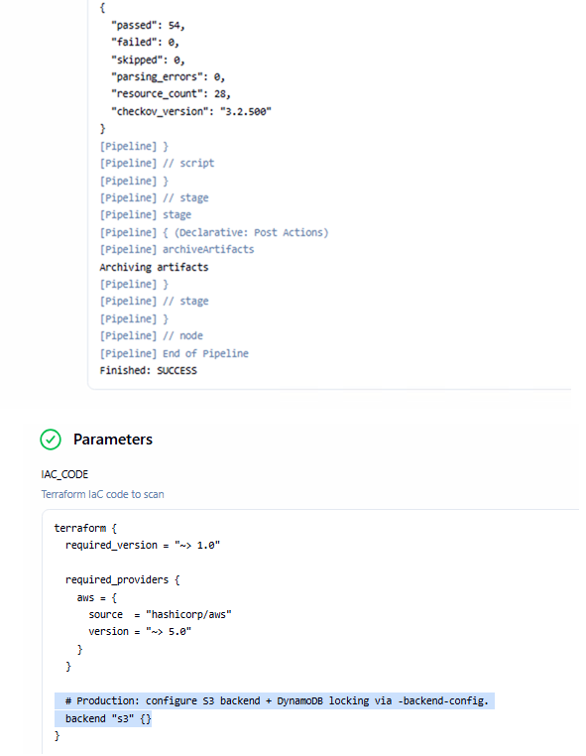
Figure A. 4 - Iteration #3: Checkov pass – S3 bucket logical error
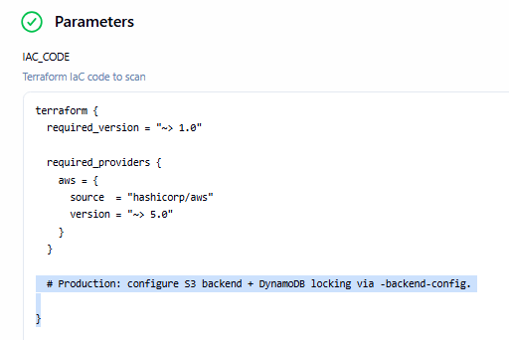
Figure A. 5 - Iteration #4: HITL removed S3 bucket logical error

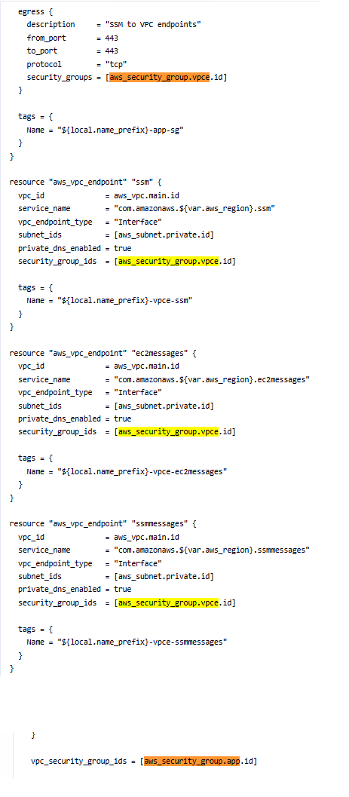
Figure A. 6 - Iteration #5: Overly restrictive egress

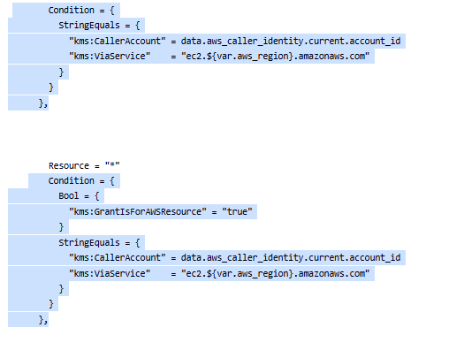
Figure A. 7 - Iteration #6: Overly Restrictive KMS Policy
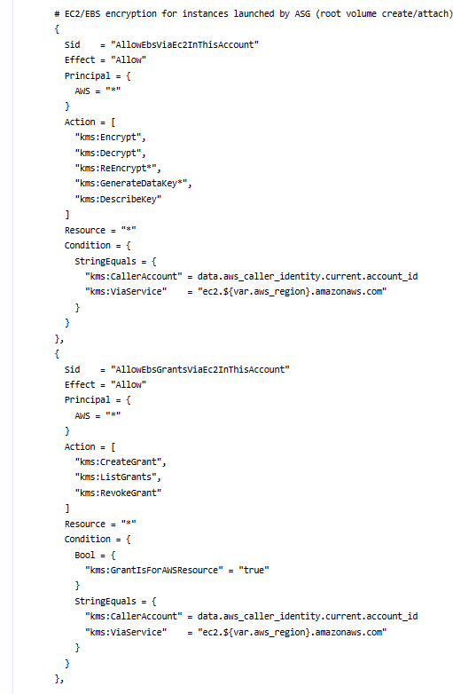
Figure A. 8 - Iteration #7: Allowing encrypt/decrypt for kms policy

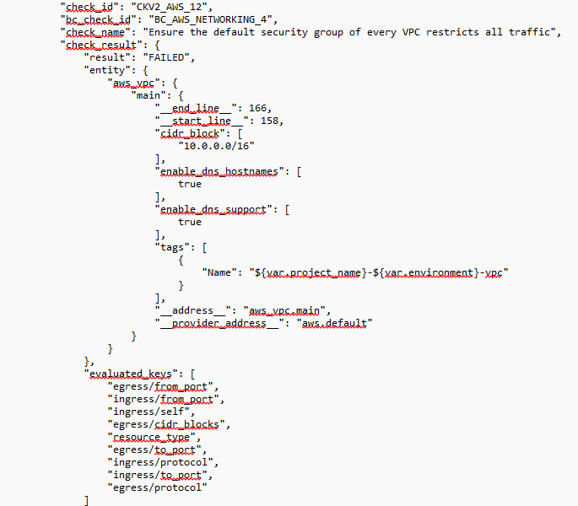
Figure A. 9 - CKV2_AWS_12 failed example
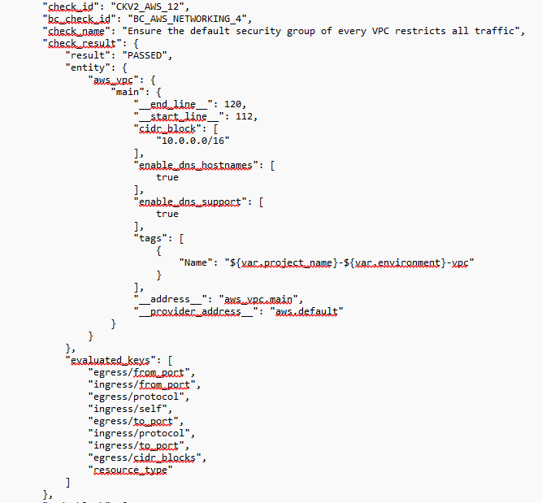
Figure A. 10 - CKV2_AWS_12 Passed example

